dotBiz Infrastructure on SCMS for GAE

Newsletter Signup Form

Overview

Where do these emails go

End-User Experience

Validation

On Submit

# Overview

The newsletter signup form collects email addresses via the Constant Contact API. When an email is submitted, the status message (success, failure, or duplicate) is passed from Constant Contact to the end user.



The footer form is differently styled but behaves identically to the home page form. This document applies to both forms.

## Where do these emails go

A: To a list called “Web Signups”

To view the list:

1. Log in to Constant Contact
2. Click Contacts
3. In the left navigation panel, click View All Lists
4. Click the Web Signups list

**If this list is deleted, the web form will return error messages to all clients.** The server uses the current Web Signups list ID (1176082800) to add contacts; renaming or deleting this list will invalidate this list ID.

# End-User Experience

## Validation

Most newer browsers (specifically any HTML5-capable browser) *automatically* notifies the user if they attempt to submit text that does not follow the format:

***somethin*g@*something*.*something***

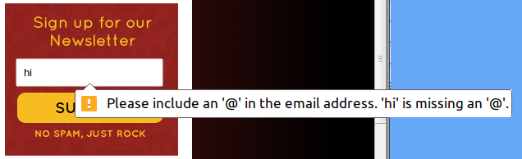

The content of these messages is built in to the browser and cannot be modified.

**Future Capability Option**

It would be possible to disable these messages and create custom ones.

## On Submit

One of three things will happen on submit:

|  |  |
| --- | --- |
|  | Email address is submitted successfully and accepted by Constant Contact. |
|  | Email address is submitted successfully but already exists as a Contact. The link points to the Constant Contact-hosted subscription preferences form for Rocketeria. |
|  | An error occurred.  Possible Causes:   * Constant Contact rejected the email * The Rocketeria web server errored * The Rocketeria web server or the Constant Contact API server was unreachable * Any other unexpected condition   Specific information can be found in the Rocketeria web server logs. The link points to the Constant Contact-hosted signup form for Rocketeria. |